**Study Sheet**

Please study the location of these land regions.

* Highland Rim
* Cumberland Plateau
* Alabama Valley and Ridge
* Piedmont Upland
* East Coastal Plain

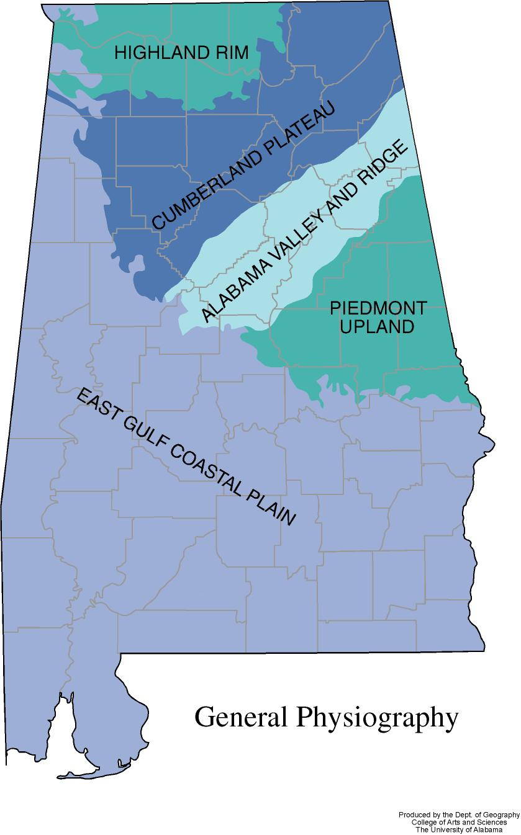

Please study the location and names of these rivers.

* Tennessee River
* Chattahoochee River
* Coosa River
* Tombigbee River
* Alabama River

**Tennessee River**

**Chattahoochee River**

